**INTERNSHIP PROJECT REPORT**

(Project Term January-April, 2016)

**“WeAssist”**

Submitted by

**Sandeep Singh**

**Registration Number: 11201761**

**Course Code CSE441**

Under the Guidance of

**Mr. Sami Anand,**

**Assistant Professor,**

**Lovely Professional University**

**School of Computer Science and Engineering**



**DECLARATION**

We hereby declare that the project work entitled WeAssist is an authentic record of our own work carried out as requirements of Internship project for the award of degree of B.Tech in “Information Technology” from Lovely Professional University, Jalandhar, under the guidance of **Mr. Ritesh Tandon** (Senior Software Developer, Lovely Infotech) **Mr. Rakesh Plaha**(External Industry Coordinator) and **Mr. Sami Anand** (Internal Faculty Advisor) during January to May 2016. All the information furnished in this internship project report is based on our own intensive work and is genuine.

Name of Student: Sandeep Singh Registration Number: 11201761

(Signature of student)

Date:



**CERTIFICATE**

This is to certify that the declaration statement made by this group of students is correct to the best of my knowledge and belief. They have completed this Internship Project under my guidance and supervision. The present work is the result of their original investigation, effort and study. No part of the work has ever been submitted for any other degree at any University. The Internship Project is fit for the submission and partial fulfillment of the conditions for the award of B.Tech degree in Computer Science and Engineering from Lovely Professional University, Phagwara.

**Signature**

**Name of the Mentor**

Mr. Sami Anand

**Designation:**

Assistant Professor,

Lovely Professional University

**School of Computer Science and Engineering,**

Lovely Professional University,

Phagwara, Punjab.

Date :

**ACKNOWLEDGEMENT**

The satisfaction that accompanies the successful completion of the task would be incomplete without the mention of the people whose ceaseless corporation made it possible, whose constant guidance and encouragement crown all efforts with success. We are grateful to our project guide Mr. Sami Anand for the inspiration and the constructive suggestions that helped us in preparation of the project “WeAssist”. His valuable guidance has leaded us towards the definite approach.

Sandeep Singh

**TABLE OF CONTENTS**

Cover page (i)

Declaration (ii)

Internship Certificate (iii)

Certificate (iv)

Acknowledgement (v)

Table of Contents (vi)

List of figures (x)

1. Organization Overview 1

1.1 Organization Departments 2

1.2 Feature of InfoTech 2

2. Introduction and Scope Of Project 4

3. Problem Analysis 5

3.1 Feasibility Analysis 5

4. Requirements 7

4.1 Hardware Requirements 7

4.2 Software Requirements 7

4.3 Memory Requirements 7

5. Profile Of The Problem 9

6. Solutions/Approach 10

7. Preface 11

7.1 Purpose of this document 11

7.2 Existing System 11

7.3 Objectives 11

7.4 Scope of Project 12

8. Software Requirements Analysis 13

8.1 Functional Requirements 13

8.2 Non Functional Requirements 14

9. Project Modules 15

9.1 Admin module 15

9.2 User management module 15

9.3 API’s used 15

10. Module Description 16

10.1 Admin module 16

10.2 Users Management module 17

10.2.1 Agent module 17

10.2.2 Worker module 19

10.2.3 Customer module 20

11. Design 23

11.1 System module 23

11.2 Logical Design 23

11.3 Detailed Design 23

12. Data Flow Diagram(DFD) 25

12.1 DFD Symbols 25

12.2 DFD Levels 26

13. Entity Relationship Model (ER Diagram) 30

14. Database Structure 34

15. Project Screenshots 35

15.1 Home Page 35

15.2 Agent 40

15.3 Worker 42

15.4 Customer 44

15.5 Admin 48

16. Architecture 51

17. Testing 52

17.1 Functional Testing 52

17.2 Structural Testing 52

18. Conclusion 54

19. Future Scope Of The Project 55

Bibliography 56

**List of Figures**

**S.No. Figure No. Name of figure Page No.**

1. 12. 1 DFD Level 1 26

2. 12.2 DFD Level 2 26

3. 12.3 DFD Level 3(i) 27

4. 12.4 DFD Level 3(ii) 27

5. 12.5 DFD Level 4 28

6. 12.6 DFD Level 5 29

7. 13.1 ER Diagram for admin 31

8. 13.2 ER Diagram for agent, worker 32

9. 13.3 ER Diagram for customer 33

10. 14.1 Database Structure 34

11. 15.1 Website Home page 35

12. 15.2 Login using LinkedIn 36

13. 15.3 Login using Google 36

14. 15.4 Service location Map 38

15. 15.5 Booking an appointment 38

16. 15.6 Our Services 39

17. 15.7 Search 39

18. 15.8 Agent Dashboard 40

19. 15.9 Add Worker 40

20. 15.10 Agent My profile 41

21. 15.11 All Worker 41

22 15.12 My Jobs Agent 42

23. 15.13 Worker Dashboard 42

24. 15.14 Worker My Job 43

25. 15.15 Customer Dashboard 44

26. 15.16 Customer My Profile 44

27. 15.17 Customer Job Creation 45

28. 15.18 Customer job listing 45

29. 15.19 Customer Feedback 46

30. 15.20 Customer Chat 46

31 15.21 Agent chat 47

32. 15.22 Email template for job creation 47

33. 15.23 Job Listing 48

34. 15.24 Admin login 48

35. 15.25 Admin Dashboard 49

36. 16.1 MVC Architecture 51

1. ORGANIZATION OVERVIEW

**L**ovely **P**rofessional **U**niversity is one of the few Indian universities, which can boast of its state-of-the-art computing resources and network across the campus. LPU believes in utilizing the technology to the fullest, and to retain its position as one of the best IT-enabled universities.

**Lovely InfoTech,** headed by **Mr. Vinay Anand** (Associate Director), is one of the most important divisions of the Lovely Professional University. It is responsible for the transmission and storage of information, especially the development, installation, implementation, and management of computer systems within university, and other organizations. The main focus of Lovely InfoTech is to understand the requirements of various departments of LPU and develop software and web portals so as to meet the specific requirements.

Lovely InfoTech is the software arm of the university that is providing the much needed IT support to make the entire system of LPU efficient and reliable. Lovely InfoTech is involved in the development and implementation of IT projects for LPU. These projects also provide hands on experience to the students in handling technology. A special wing of Lovely InfoTech employs promising LPU Computer Science Students, for software development work.

**1.1 Lovely InfoTech Division has Four Departments:**

1. **Department of Software Development**

This department uses Technology asp.net, C#, vb.net and developing the asp projects. Now this department id divided into four cells.

**Group Heads.**

Cell 1. **Mr. Bhupinder Singh**

Cell 2**. Mr. Gurpreet Walia**

Cell 3. **Mr. Lakhwinder Singh**

Cell4. **Mr. Ritesh Tandon**

1. **Website Development (PHP, CSS design, etc.) Cell**

This Cell is using technology PHP for the development. The H.O.C of website development cell is Vinay Anand.

1. **IT Data Centre Cell**

This department mainly works on the server administration, cabling and networking. The H.O.D of this department **Mr. Vinay Anand.**

1. **Student Training IT Cell**

This department conducts industrial training for the students pursuing either MCA or B-Tech. The C.O.C of this cell is **Mr. Rakesh Plaha.**

**1.2 Some of the features of Lovely Info-Tech are as follows:**

* Dedicated iMac Lab for IPhone application development.
* Completely Wi-Fi Campus with 1500+ access point, supported on the technology from RUCKUS and CISCO.
* 1 Gbps of bandwidth for internet with dedicated leased line.
* 6000+ workstations supported by 50 plus Quad Core or Xeon based Rack/Blade and desktop Servers.
* 50 servers from HP/IBM for 100% redundancy and efficient data management.
* High end Security firewall featured network.
* 24hrs Power Back-Up 1000 KVA of on line uninterrupted power supply(UPS).

Lovely InfoTech is involved in the development and implementation of IT project for LPU.These projects also provide hands on experience to the students in handling technology.

**Some of the major projects developed by Lovely InfoTech are:**

* Learning Management System (LMS)
* Relational Management System (RMS)
* HR Management System
* Inventory Management System (IMS)

2. INTRODUCTION AND SCOPE OF THE PROJECT

“WeAssist” provides home repair, seasonal maintenance and emergency services to homeowners, strata property managers and commercial customers throughout the Lower Mainland. Our professional handymen are bonded, licensed and insured, and our service vehicles are equipped to take care of all minor repairs immediately. Whatever your project, we’ll make sure it’s done right.

“WeAssist” provides speedy and effective handyman services. A full report detailing the expected scope of work will be given to homeowners following a full inspection of the problem. Most jobs will be completed within 72 – 96 hours, giving you the peace of mind that your clients will be taken care of. If repairs need more time, we gladly provide detailed timelines to assure you and your clients that they will be done as quickly as possible.

“WeAssist” strives to make your job easier. We’ll communicate with homeowners directly so that you don’t have to worry that the job is being done right. Our management and experienced handymen will provide homeowners with any assistance they require, making sure that the only thing on their minds is satisfaction with our services.

Most repairs will be attended to by a carpenter. While most jobs will often use a helper or labourer to aid in completing repairs, there are some circumstances where two carpenters will be needed.

We are best suited to make repairs on jobs with a limited price. “WeAssist” is ready to deliver the quality workmanship we are known for.

Thus, this Project will provide the user better medical services on his fingertips. Just by click of a button it can have so many facilities anytime and anywhere. This system will facilitate Customer as well as worker. The whole system can be automated with the help of this project. We can further elevate this project by implementing more services in it like payment, shop facility to make it more easy.

3. PROBLEM ANALYSIS



Figure 3.1 Problem Analysis

**3.1 Feasibility Analysis: -**

The feasibility study is an evaluation and analysis of the potential of project is based on extensive investigation and research to support the process of decision making. The interface should be much interactive so that it can be easily used by everybody.

The acronym “TELOS” refers to the five main areas of feasibility study. These feasibility studies are Technical, Economic, Legal, Operational and Scheduling. In WeAssist we have to evaluate all these 5 parameters that whether this project can be implemented or not.

**Technical Feasibility:**

The technical feasibility is an evaluation of the hardware and software and how it meets the need of the proposed system. In “WeAssist” we have all the kinds of software’s available which can interact with each other and help us to achieve the desirable task.

**Economical Feasibility:**

“WeAssist” will be economically efficient as we need not any kind of files and folders to store information. No need to pay money to the evaluator as no physical appearance of the student is needed.

**Legal Feasibility:**

It determines whether the proposed system conflicts with legal requirements.

For example, a Data Processing system must comply with local Data Protection Acts.

**Operational Feasibility:**

Operational feasibility is a measure of how well a proposed system solves the problems and how it satisfies the requirements identified in the requirements analysis phase of system development.

**Schedule Feasibility:**

A project will fail if it takes too long to be completed before it is useful. Typically this means estimating how long the system will take to develop, and if it can be completed in a given time period. Some projects are initiated with specific deadlines. It is necessary to determine whether the deadlines are mandatory or desirable.

**4. REQUIREMENTS**

**4.1 HARDWARE REQUIREMENTS**

The PHP is the default scripting language implemented with the Apache or any other web server installed at the server where the PHP should be executed. If your server supports PHP, then you do not need to do anything. Just create your .php files, put them in your web directory and the server will automatically parse them for you

**Hardware requirements:**

* Hard disk: - 340 MB
* Minimum at least 256 MB of RAM. As with all database-driven applications, more RAM is advisable.
* Processor: -AMD or Celeron Processor

**4.2 SOFTWARE REQUIREMENTS:**

Run PHP on your system the easiest way to do this to install a complete package of xampp / wamp. this contain the apache web server, along with PHP and the MYSQL database engine. XAMPP is available for windows, MAC ,OS X and linux.

**Software requirements:**

* WAMP/XAMPP --- Web Application Server
* PHP --- Server Side Scripting Language
* MySQL --- Database
* HTML5 & CSS3
* EditPlus/Sublime Text Editor/Notepad++ --- As a development tool
* Browser--- Mozila Firefox/Chrome

**4.3 MEMORY REQUIREMENTS:**

The project requires minimalistic memory as per the industry standards and PHP server requirements, it requires a minimum of 8GB RAM for server. Client side requires a browser and a minimum of 512 MB RAM. Usually, that memory limit is ignored unless support for it has been compiled into PHP (or if you are running PHP as CGI) and doesn't cause any problems.

1. **LANGUAGE REQUIREMENTS:** PHP (recursive acronym for PHP: Hypertext Preprocessor) is a widely-used open source general-purpose scripting language that is especially suited for web development and can be embedded into HTML.

* **INTERFACE:**

PHP uses XAMPP / WAMP for user interface.

* **SECURITY:**

Each release branch of PHP is fully supported for two years from its initial stable release. During this period, bugs and security issues that have been reported are fixed and are released in regular point releases.

After this two-year period of active support, each branch is then supported for an additional year for critical security issues only. Releases during this period are made on an as-needed basis: there may be multiple point releases, or none, depending on the number of reports.

**5. PROFILE OF THE PROBLEM**

The existing system may not suit in situations of emergency**.** Walking or other mediums may consume a lot of time when somebody is having problem.

* Need to establish a schedule of work to be done.
* Difficulty in finding workers
* Need to go to the worker manually for small problems
* Difficult to remember dates of appointments
* Make sure you’re comfortable with how they price their work.
* Difficult to search nearby candidates.

**6. SOLUTIONS/APPROACH**

Our services provide quick resolution to the growing list of To-Do’s and keep your home in perfect shape.

* Provide trusted services to customer.
* We provide bunch of workers to quickly respond your needs.
* Our services operate on different cities
* Easy to hire and get home improvement anytime.
* Easy access of information by various categories and subcategories of services.
* Provide emergency plumbing or other repair jobs

Here we provide all services, including the pitfalls and what you should expect if you hire a handyman to assist with things around the house

7. PREFACE

7.1 Purpose of this Document

This training manual aims to familiarize you with the computerized tasks and processes of the “WeAssist” project development.

**Intended Audience** This Project is intended for users of web-developers and compatible with mobile system on their phones especially users like handyman workers, customers and job-seekers. It will enable them to understand all aspects of the system in detail.

* 1. **Existing System**

Existing systems exists where user can add an appointment whereas proposed system has functionalities which provides unique features including online chat, notifications, payment and a unique methodology for agents and workers. There are lot many features in proposed website to satisfy the users i.e. workers as well as customers. These factors motivated us to come up with the idea to develop this website which will provide efficient hiring system and would be beneficial for people.

**7.3 Objectives**

For web development using PHP, which includes

a. Providing user friendly interface for all type of users

b. creating jobs, accept jobs and hire worker online

c. Create jobs by Customers.

d. Uploading and viewing job and user’s images

e. Tools for better search.

f. Total jobs, completed jobs and pending job charts

g. Admin to worker, Admin to Agent and Admin to customer chat

h. Well-Maintained Internal and External privacy

**7.4 Scope of Project:**

Completion of the development process will result in a web development that will provide user-friendly environment, which will enable the user to do several things on the click of a button. There is no need to rush to the go outside for small problems like if a person is having a problem, he/she can sign up and hire a person who is specialized in his field for the cure by just using this website. Jobs can also be creating by this website. Moreover, the agent can add worker by himself and worker is referenced by the same agent, and unique code is generated for each agent, agent and worker can view their jobs, hire many workers for the same or different problems or issues, post a job, view number of workers working under particular agent. In future we can implement some alarm functionality in it for the user to online payment facility. Thus, it can better serve the society to resolve home related issues and becoming more easy, secure and reliable.

**Practicality:** The system is quite stable and can be operated by the people with average intelligence.

**Efficiency:** I tried to involve accuracy, timeliness and comprehensiveness of the system output.

**Cost:** It is desirable to aim for the system with a minimum cost subject to the condition that it must satisfy the entire requirements.

**Flexibility:** I have tried that the system should be modifiable depending on the changing needs of the user. Such modifications should entail extensive reconstructing or recreation of software. It should also be portable to different computer systems.

**8. SOFTWARE REQUIREMENT ANALYSIS**

**Introduction:**

The project WeAssist is related to provide online services to customers. The idea is based on to provide lower level services to customers like plumber, electrician, constructor, home-security, doctors, recovery-services, designers, and many more.

**8.1 Functional requirements: -**

These requirements analyzed to measure the level of detailed view of project, sufficient to enable designers to design the system and testers to test the system.

**Registration Form:**

Signup using facebook/google/linkedin

1. First Name
2. Last Name
3. Email-id
4. Password
5. Confirm password
6. Reference code for Worker only
7. User type: Agent, Worker, Customer

**Login Form:**

Login Using Google/ facebook/ linkedin

1. Username
2. password

**Agent Dashboard**

1. Add Worker - First Name, Lastname, Email
2. MyProfile- Firstname, Lastname, City, Image, Contact

**Customer Dashboard**

1. Create job - Job Category, Subcategory, Job title, Job description, job Price, Date, Time, Job Photo
2. MyProfile- Firstname, Lastname, City, Image, Contact, Choose Multiple Subcategories
3. Change Password – Old password, NewPassword, ReType new password

**Worker Dashboard**

1. MyProfile- Firstname, Lastname, City, Image, Contact
2. Change Password – Old password, NewPassword, ReType new password

**8.2 Non Functional requirements: -**

Characteristics of the system which cannot be expressed as functions are maintainability, portability, usability, Interface with other external systems, Security, Availability etc.

9. PROJECT MODULES

* 1. Admin Module

9.2 User Management Module

* + - Agent Module
    - Worker Module
    - Customer Module

9.3 API’s used

* API for Facebook Login
* API for Google Login API
* API for Linked Login
* API for Pusher chat
* API for Algolia search
* One signal
* API for Google map
* Send Grid API for sending emails

10. MODULE DESCRIPTION

* 1. **Admin module:**

This module will contain various types of user’s details, like update, delete, add new user /update, delete, edit and add new categories or subcategories. It also provides list of all type of users, referred users, and job details created by the customers. It also maintains the details of these three types of users. Admin can modify records; he can update, delete, add users.in this module we provide we provide the chat system of admin with three types of users.

**Submodules:**

* Update user details.
* Unregister user.
* Update Category/Subcategory Details
* Remove Category/Subcategory

**Update user details:**

In this sub module we can update the details of the user like customer/worker name, address, contact number, e-mail_id, etc. And we store these details in database.

**Unregistered the user:**

In this sub module we delete the details of the user like customer/worker name,

address, contact number, e mail_id, password and report by taking the primary constraint email_id. And it also deletes these details in database.

**Update Category/Subcategory details:**

In this sub module we can update the details of the category/subcategory like category/subcategory name, image, description, city etc. And we store these details in database.

**Remove Category/Subcategory:**

In this sub module we delete the details of the user like category/subcategory like category/subcategory name, image, description, city etc. And it also deletes these details in database.

**Chat System:**

We provide a live chat of admin with all type of users. This facility leads to solve personal and professional project issue and problems and remove communication gap between project team members. This tool will make easy and smooth flow of information.

* 1. **User Management Module:**

In this module there are the three types of registration; i.e. one for Agent registration, one for worker registration and the other one is for customer registration.

All three types of users can signup and login through facebook, google, linkedin.

**10.2.1 Agent Module:**

This module is having a separate registration option**.** Under this module any new Agent can register himself. Registered Faculty can have three options by Facebook, Google, and Linked in and then login himself that redirect to agent dashboard. Where he or she can also change his or her details and maintain their own identity.

They can chat, add worker or view number of worker working under them, edit profile, see job list and accept jobs etc.

Moreover, he can search the professionals according to his requirement.

**Submodules:**

* View Recently added users
*  Login/Register
* Add Worker.
* Chat
* Edit Profile
* Search

**View Recently Added Users:**

This module will able us to see the list of the various types of users under particular agent recently added. It also provides the ability to view all details of the workers and provides the complete information about the services of worker through map.

**Login/Register:**

There is separate option for registration of the agent type (user type). He / She can register through any of the option we provide by our external API’s. Whenever the agent is register a random code is generated as a unique code for each agent, which is further used by worker as a reference code.

**Add Worker:**

After login agent type is redirect to agent dashboard where he can add worker manually. That worker is recognized by the reference code of the same agent who added the new worker.

The worker comes under the list of agent whosoever agent registered the worker.

**Edit Profile:**

Under this module, the agent can complete his profile, his personal information like, update his First name, Last Name, City, Image, Contact, Change his password etc.

**Chat:**

In this module we Provide a chat system to ebhance the communication between agent, worker, customer and hence limit the personal and professional issues.

**Search:**

In this module the external api “algolia” search is implemented which filter the professional details or services by categories. Once user type it will show all categories list. on clicking that particular category option, we can view all realated information about that particular category included ranking, description, available city etc.

**10.2.2 Worker module:**

This module is having separate registration too**.** In thismodule every worker who

haven ‘t register himself can register himself. Worker can be registered by agent also.

Worker has to fill code given by the refered user. He can also change his details and maintain their own identity. And then after Login himself he can view the list of jobs for wh select whatever course he ich the corresponding worker related to. Registered worker can edit profile and can submit any query, can give feedback, search for professional etc.

**Sub modules:**

* Login/Register[Google/Facebook/Linkedin]
* Edit Profile
* Choose Multiple Categories/Subcategories
* Chat
* Accept/Reject Jobs
* View Job Details
* Search

**Login/Register:**

There is separate option for registration of the worker type (user type). He / She can register through any of the option we provide by our external API’s. There are two options for registration of worker, by agent or by worker himself. Whenever the agent is register a random code is generated as a unique code for each agent, which is further used by worker as a reference code (in case of worker himself).

**Edit Profile:**

Under this module, the agent can complete his profile, his personal information like; update his First name, Last Name, City, Image, Update Ctegory or Subcategory, Contact, Change his password etc.

**Choose Multiple Categories/Subcategories:**

This module allows the worker to choose more than one category because there could be a possibility that one person is expert of many services. This feature can increase the availability of single workers in more than one service. Once he chooses the categories, the subcategories fields are fetch from these category list which reduce redundancy.

**Chat:**

In this module we Provide a chat system to enhance the communication between agent, worker and hence limit the personal and professional issues.

**Accept/ Reject jobs:**

This module shows all information of the customers who post their jobslike jobcategory, jobsubcategory, job title, job image, job description, job price, time period. The worker can accept or reject that jobs and stote the status in database, which will help in counting total jobs, completed jobs, pending jobs.

**Search:**

In this module the external api “algolia” search is implemented which filter the professional details or services by categories. Once user type it will show all categories list. On clicking that particular category option, we can view all related information about that particular category included ranking, description, available city etc.

**10.2.3 Customer module:**

This module is also having separate registration option**.** In thismodule every customer who signedup can then login and redirect to customer dashboard

He can also change his details and maintain their own identity. And then after Login he can post jobs view the list of jobs which he has created.Registered customer can edit profile and can submit any query , can give feedback ,post a job and search for professional filtered by various categories and subcategories etc.

It also provides the ability to change password and can edit other personal details .

**Submodules:**

* Post Jobs
* Give Feedback
* Search
* Login/Register
* View Professional Lists
* View Job Details
* Edit Profile
* Chat

**Post Jobs:**

After login as a customer, in customer dashboard, the customer can create his job/or multiple jobs. where he has to fill complete information about the jon like job category, subcategory, job description, job title, job completion date, time, job price and job photo. The worker can accept or reject these jobs.

**Give Feedback:**

The customer can give feedback according to his perception. It will help to improve the limitations and help in improve the flow of work/services.

**Search:**

In this module the external api “algolia” search is implemented which filter the professional details or services by categories. Once user type it will show all categories list. On clicking that particular category option, we can view all realated information about that particular category included ranking, description, available city and request for hire the worker etc.

**Login/Register:**

There is separate option for registration of the Customer type (user type). He / She can register through any of the option we provide by our external API’s.

The user type as customer is stored in the database. After login person is redirected to customer dashboard.

**Edit Profile:**

Under this module ,the agent can complete his profile ,his personal information like,update his FirstName ,Last Name, City, Image, Contact, Change his password etc.

**Chat:**

In this module we Provide a chat system to enhance the communication between agent, andCustomer and hence limit the personal and professional issues.

**View Professional List:**

This module is in the main dashboard where the customer can view all the professionals with their services. He can get every professional’s details like name, category/subcategory of the service, city, ranking, reviews and image of the professional.

**View Job Details:**

In the customer dashboard , the customer can view how many jobs he has created, and how many of his jobs get accepted or rejected.

**11. DESIGN**

Software design is actually a multistage process that focuses on four distinct attributes of a program: data structure, software architecture, interface representation and procedural detail. The design activity is often divided into two separate phases- system design and detailed design.

Two types of design are: -

1. System design
2. Logical design
3. Detailed design.
   1. **System design :**

System design is also called top-level design aim to identify modules that should be in the system .The specification of these modules and how they interact with each other to produce the desired results.

**11.2 Logical Design :**

* Use Case Diagram or DFD(Data flow Diagram)
* Architectural Design
* ERM(Entity Relationship Model)

**11.3 Detailed Design:**

During detail design the logic of the module specified in the system has been specified. During detailed design here focus has been on designing the logic for each module.

* **Input Specification**

We apply various steps to guide the customer so that wrong input does not go on when designing input system the following conditions study has been done: -

* What data to be input?
* What medium to use?
* How data should be arranged or coded?
* The dialogue to guide the users in providing input?
* Methods for performing input, validation and steps to follow when error occurs?
* **Output Specification**

After the input designing, the next step is the output designing in the input designing we all the web pages are shown and we capture, manipulate, validate and finally store data for the registration form.

* **Frontend Tool (php)**

PHP stand for hypertext preprocessor. It is a server-side scripting language, like ASP, php scripts are executed on the server.php files:

* Php files can contain text, html tags and scripts
* Php files are returned to the browser as plain html
* Php files have a file extension of”.php”,”.php3”,or “.phtml”
* **Backend Tool (MySQL)**

MYSQL is the most popular open-source database system.SQL stands for Structured Query language. The data in MYSQL is stored in the database objects called tables, consist of columns and rows. Databases are useful when storing information categorically. One great thing about MYSQL is that it can be scaled down to support embedded database applications.

**12. DATA FLOW DIAGRAM**

The data flow diagram shows the flow of data with in any system. It is an important tool for designing phase of software engineering. It represents graphical view of flow of data. It’s also known as BUBBLE CHART. The purpose of DFD is major transformation that will become in system design symbols Used in DFD:

In the DFD, four symbols are used and they are as follows:

1. A square defines a source (originator) or destination of system data.

2. An arrow identifies data flow- data in motion. It is a pipeline through which information flows.

3. A circle or a “bubble” (some people use an oval bubble) represents a process that transfers informing data flows into outgoing data flows.

4. An open rectangle is a data store- data at rest, or a temporary repository of data.

**12.1 DFD Symbols**

Input / Output -

Data Processing -

One Way Data Flow -

Two Way Data Flow –

Data Store -

Database –

Data_Fields--

So it is the starting point of the design phase that functionally decomposes the requirement specifications down to the lowest level of details. A DFD consist of a series of bubbles joined by lines. The bubbles represent data transformation and the lines represent data flows in the system.

The diagram dataflow representation is divided into varios levels:

**12.2 DFD Levels**

**Level 1:-**

User

Database

Figure: 12.1 DFD level 1

**Level 2:**

Professionals

Login/register

Users

Agent

Admin

Customer

Worker

database

Team details

Post profile

Services

Jobs

Figure:12.2 DFD Level 2

Subscribe

**Level 3:**

Worker

Customer

Agent

Login/ Register

Facebook

Linkedin

Google

Figure: 12.3 DFD Level 3(i)

Admin Dashboard

Register

Login

Admin

Figure: 12.4 DFD Level 3(ii)

**Level 4:**

Signout

Worker Dashboard

Agent Dashboard

After Login/Register

Register

Login

Customer dashboard

Figure:12.5 DFD Level 4

**Level 5:**

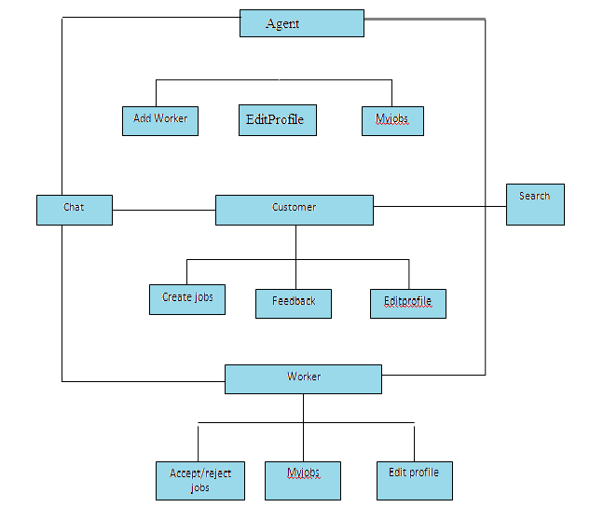

Figure 12.6 DFD Level 5

**13. ER DIAGRAM**

Entity relationship diagramsare a way to represent the structure and layout of a database. It is used frequently to describe the database schema. ER diagrams are very useful as to provide a good conceptual view of any database, regardless of the underlying hardware and software. An ERD is a model that identifies the concepts or entities that exist in a system and the relationships between those entities. An ERD is often used as a way to visualize a relational database: each entity represents a database table, and the relationship lines represent the keys in one table that point to specific records in related tables. ERDs may also be more abstract, not necessarily capturing every table needed within a database, but serving to diagram the major concepts and relationships. This ERD is of the latter type, intended to present an abstract, theoretical view of the major entities and relationships needed for management of electronic resources.

Entities: these are usually Fields used in descriptions of the system, in the discussion of business rules, or in documentation; identified in the narrative 2. Relationships: these are usually verbs used in descriptions of the system or in discussion of the business rule.

Add attributes to the relations; these are determined by the queries, and may also suggest new entities, e.g. grade; or they may suggest the need for keys or identifiers.

Figure 13.1 ER diagram for admin

**ssk**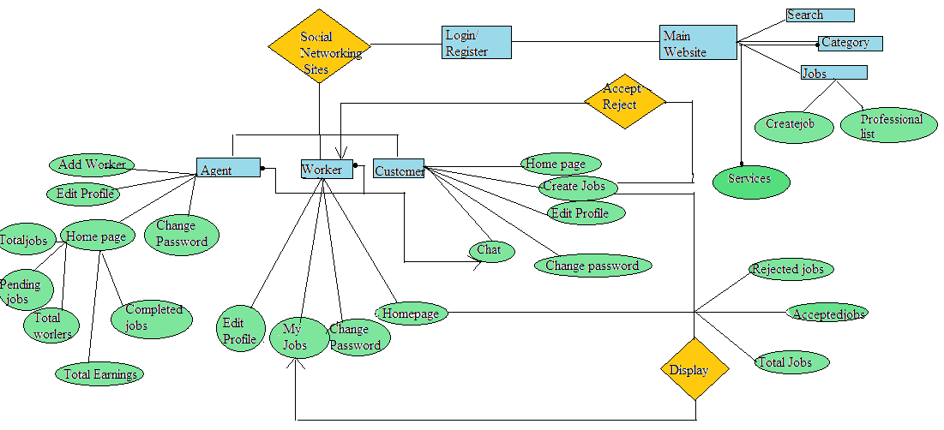

Refered users

Home Page

Users

Scheduled jobs

Subcategories

**Admin**

Categories

Figure 13.2 ER diagram for Agent, Worker

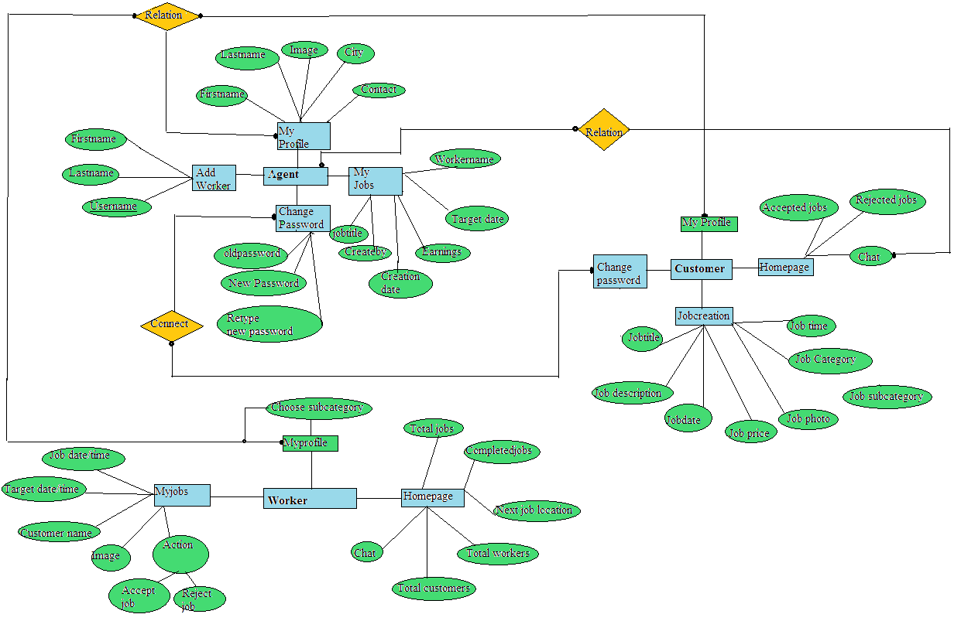 Figure 13.3 ER diagram for customer

**14. DATABASE STRUCTURE**

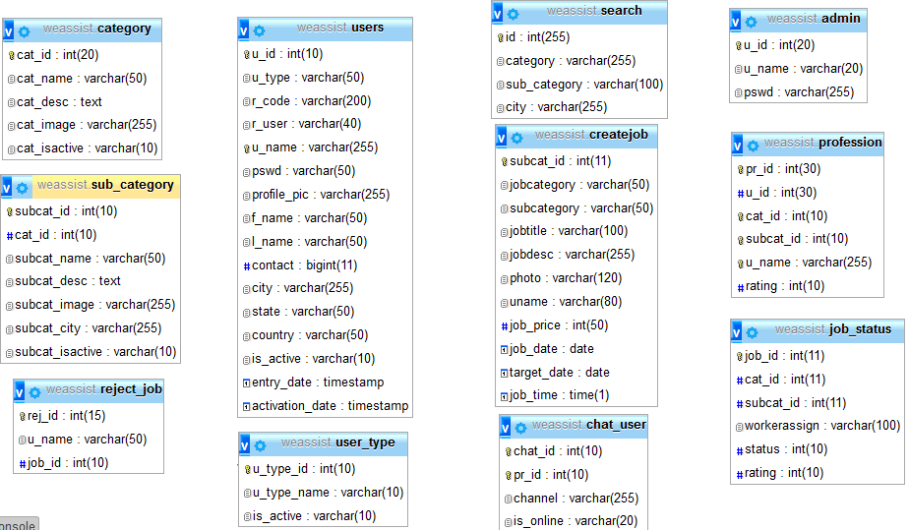

Figure 14.1 Database Structure

**15. PROJECT SCREENSHOTS**

The main aim of this project report is to highlight the features as follows: -

* To show how the project is developed.
* To show the details of database design.
* To show how the user can work with the project Interface.
* To view the external view of the website.

**15.1 HOME PAGE**



Figure 15.1 Home Page

**SIGNUP / LOGIN FORM**

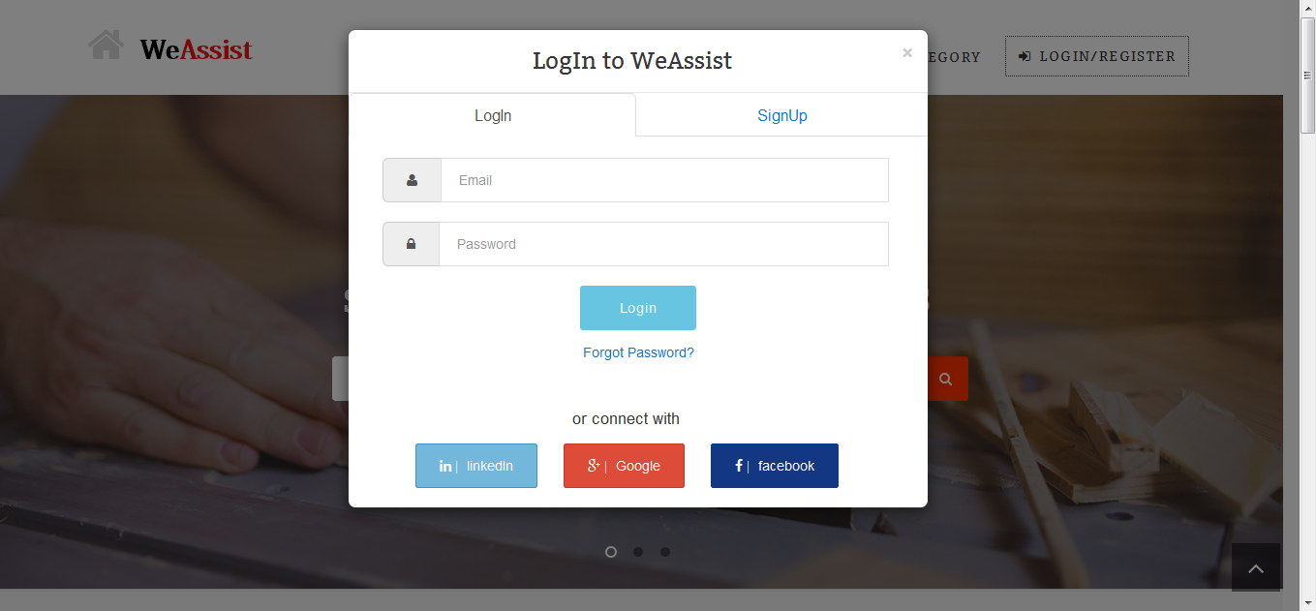

Figure 15.2 Login Page

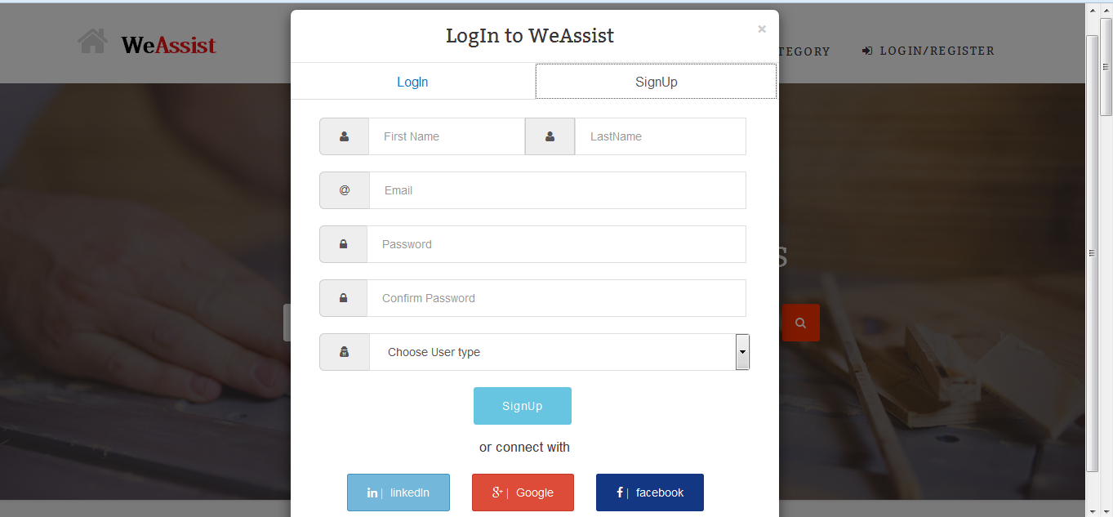

Figure 15.3 SignUp Page

**LOGIN/ SIGNUP WITH SOCIAL NETWORKING SITES**

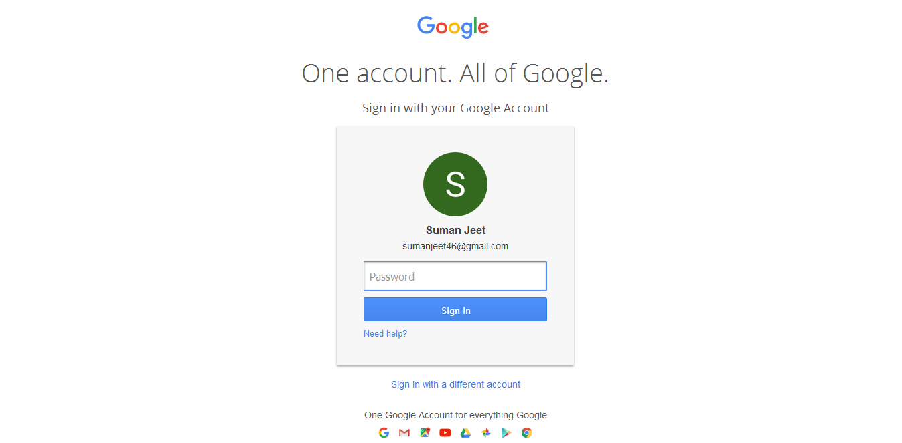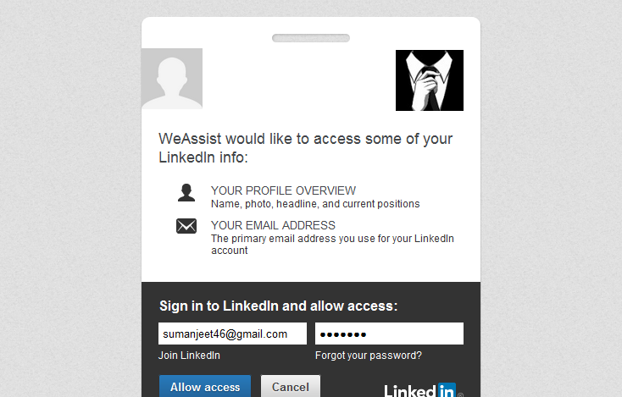Figure 15.2 Login Using linked InFigure :15.3 Login Using Google

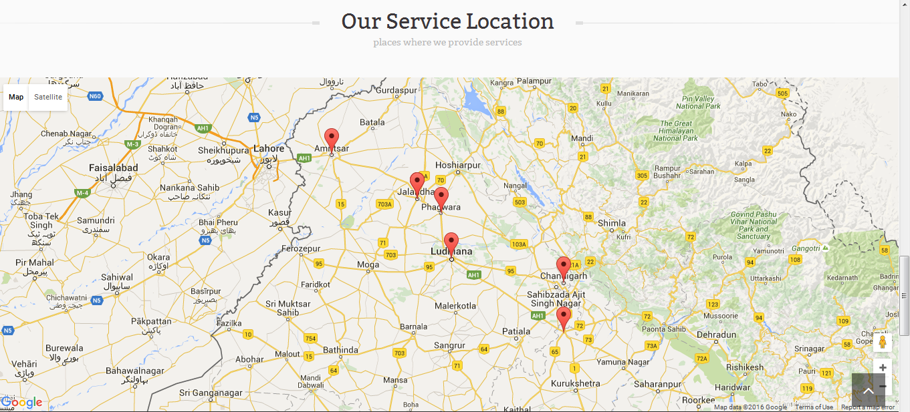

Figure: 15.4 Our Service Locations

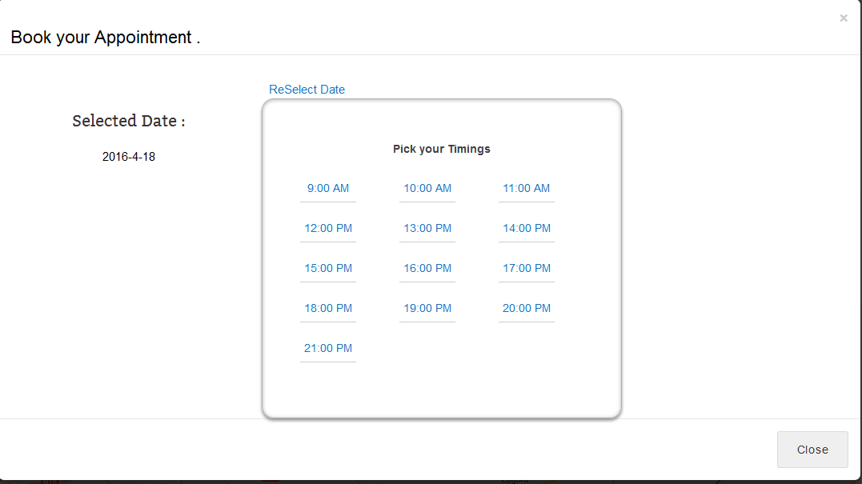  Figure 15.5 Booking an appointment

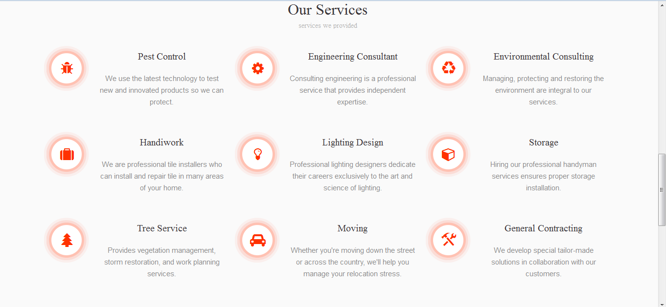

Figure 15.6 Our Services



Figure: 15.7 Search

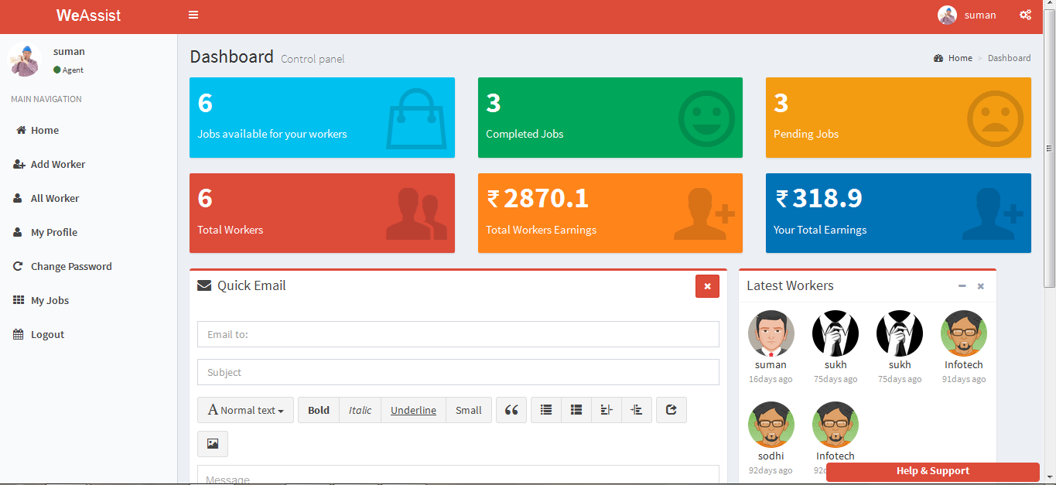

Figure 15.8 Agent Dashboard

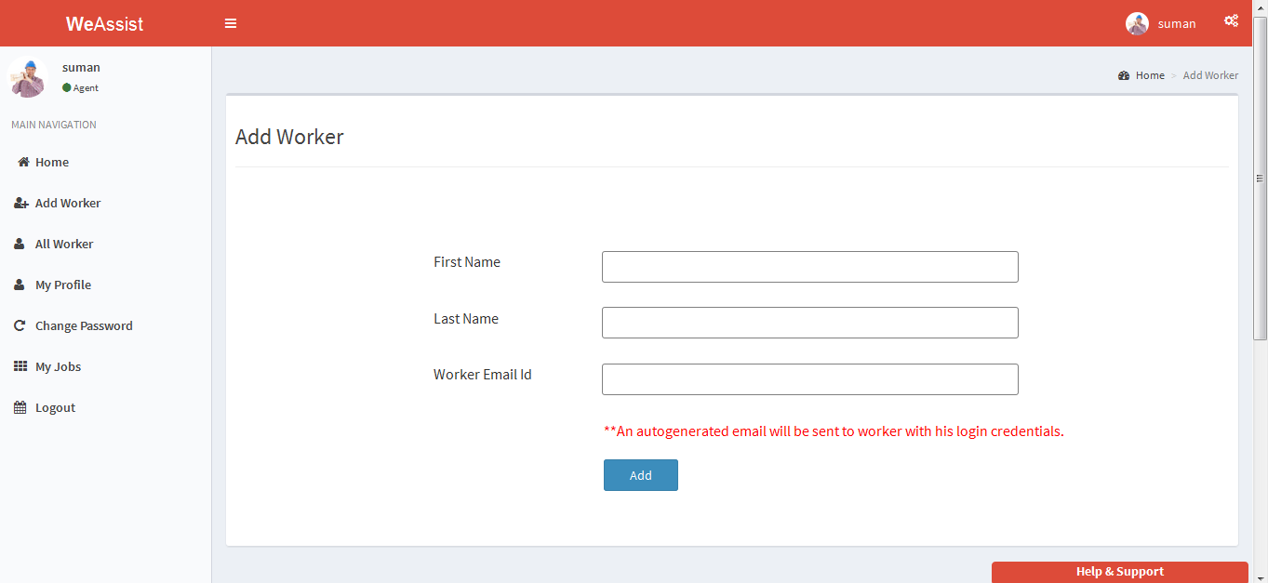

Figure 15.9 Add Worker

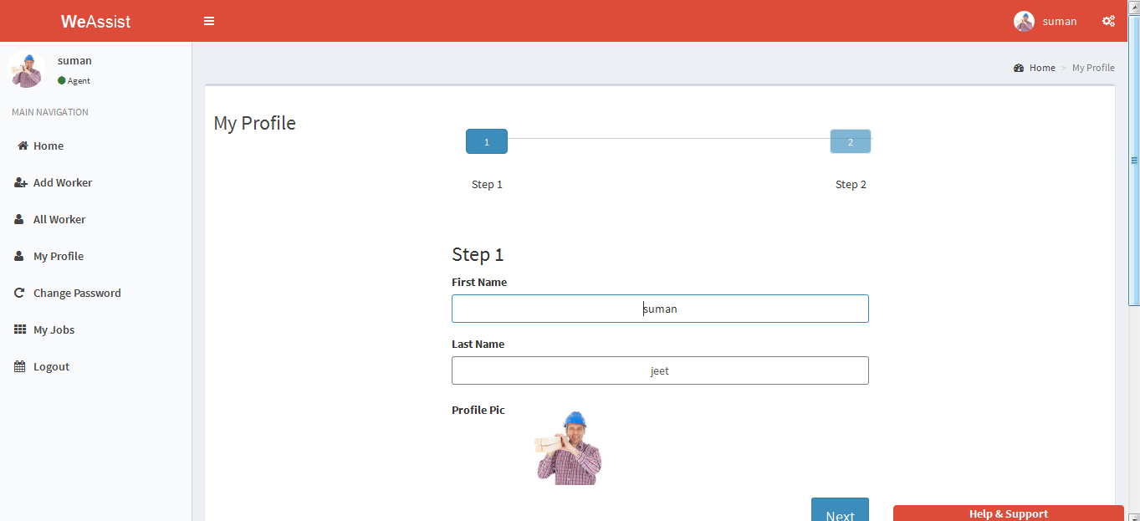

Figure 15.10 My Profile (Agent)

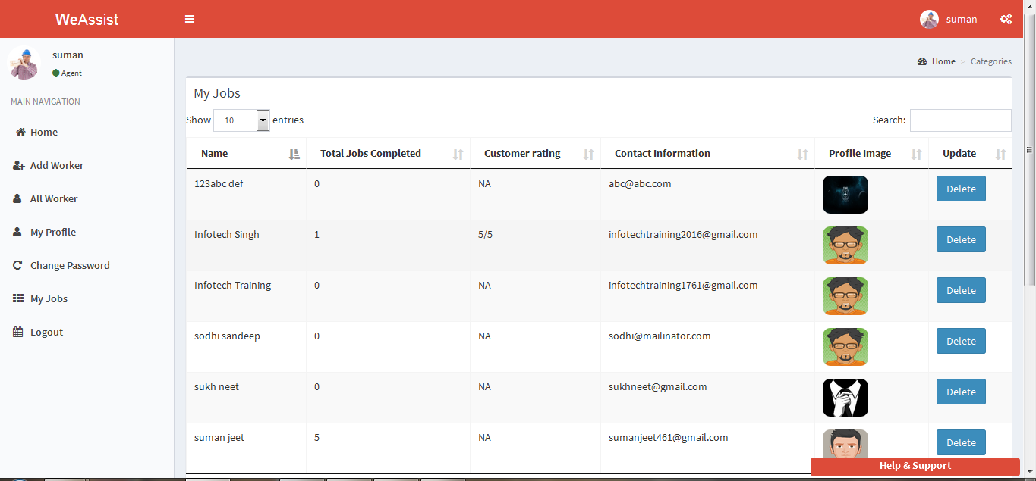

Figure 15.11 All Workers

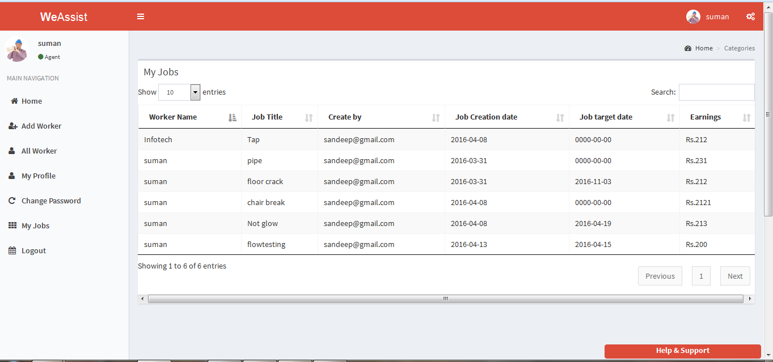

Figure 15.12 My jobs (Agent)

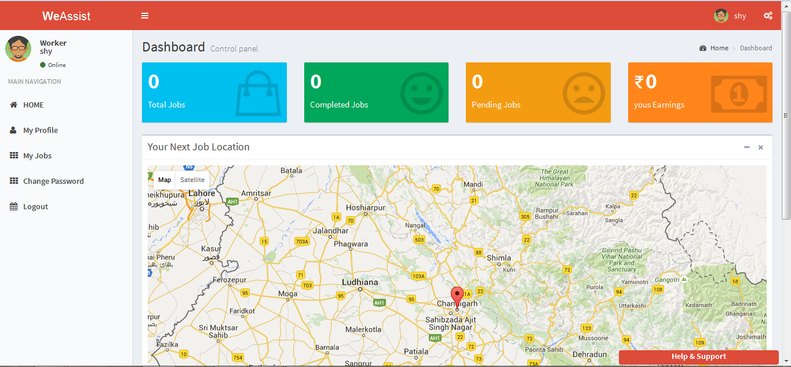 Figure 15.13 Worker Dashboard

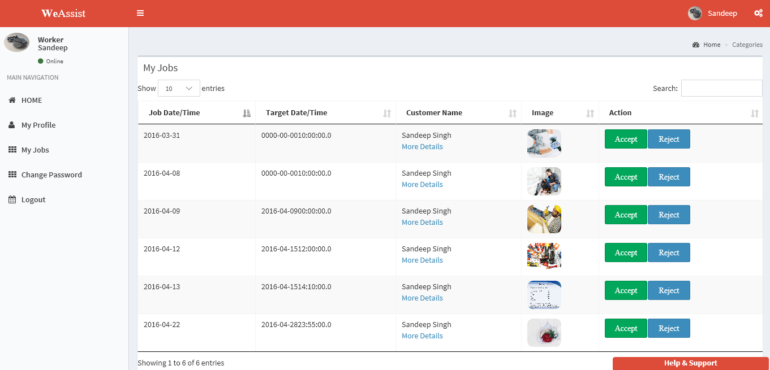

Figure:5.14 My Jobs

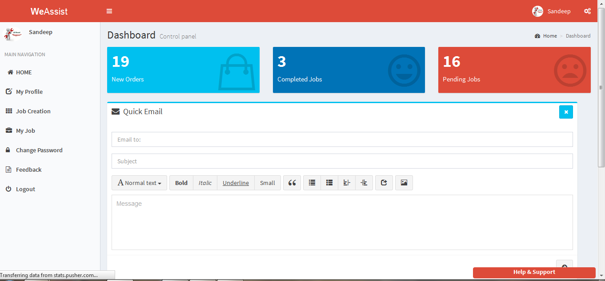

Figure:15.15 Customer Dashboard

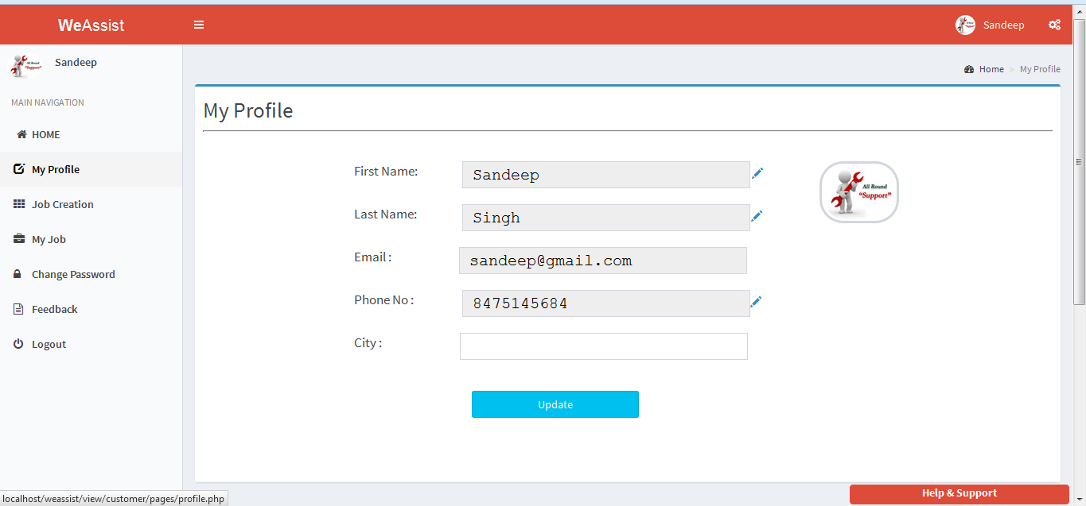

Figure 15.16 My Profile (Customer)

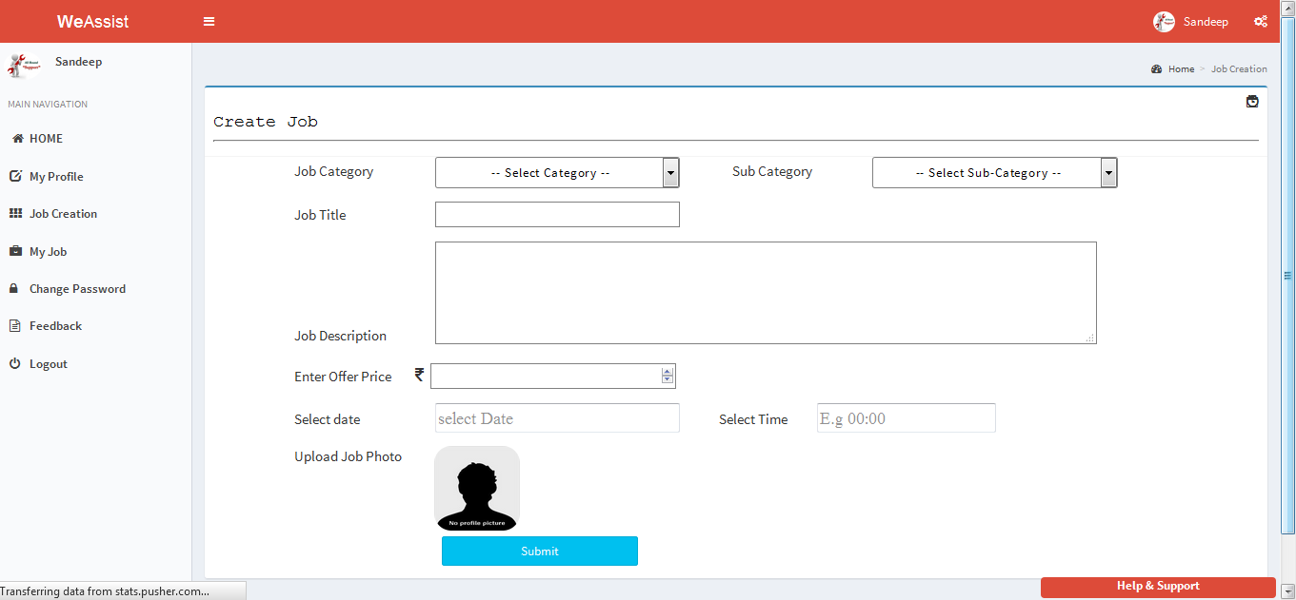

Figure:15.17 Job Creation

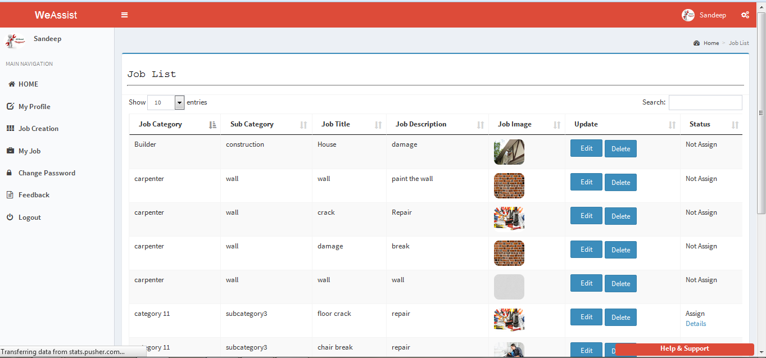

Figure: 15.18 Job Listing

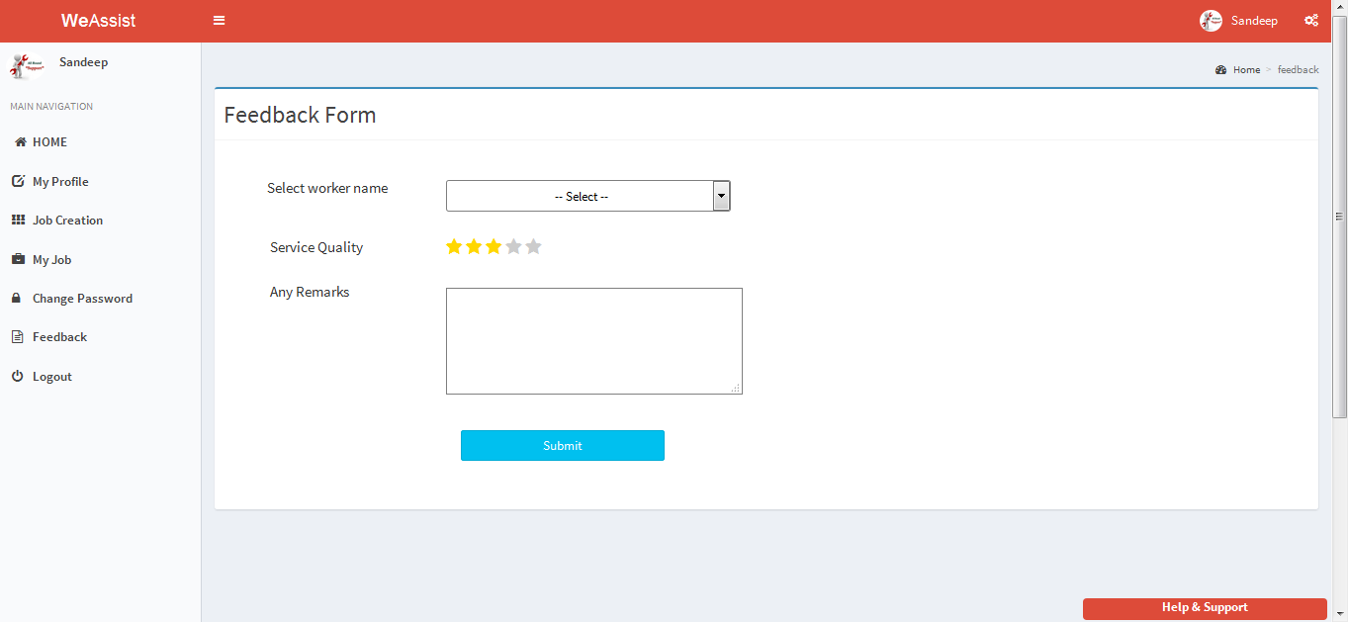

Figure: 15.19 Customer Feedback

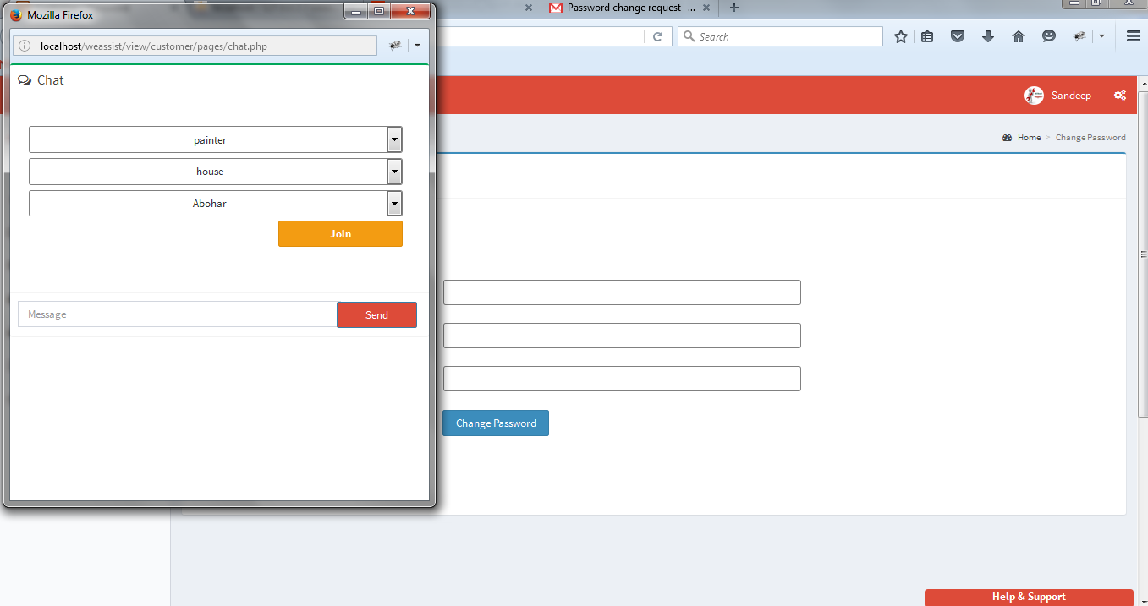

Figure 15.20 Customer Chat

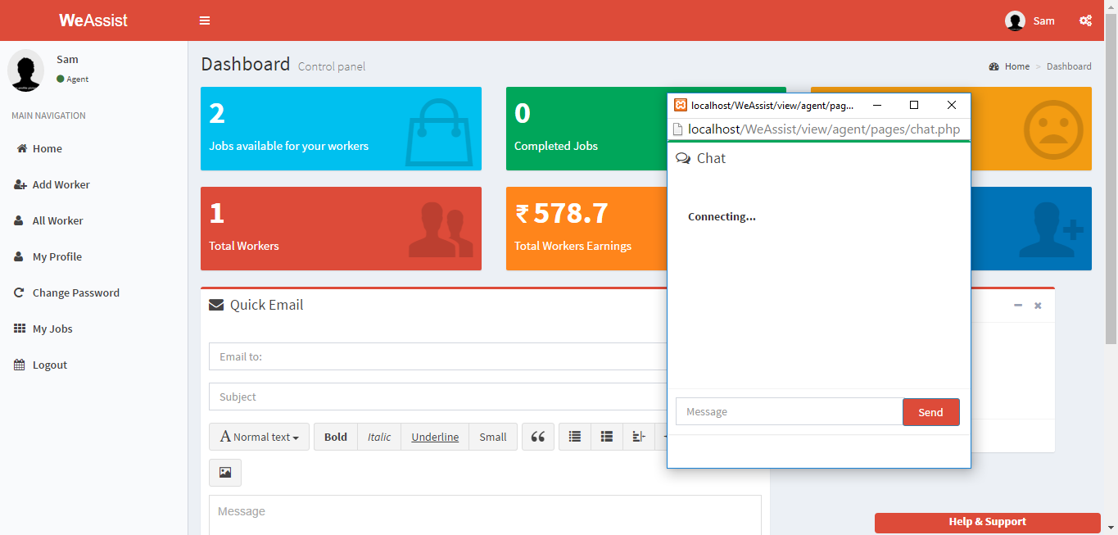

Figure 15.21 Agent Chat

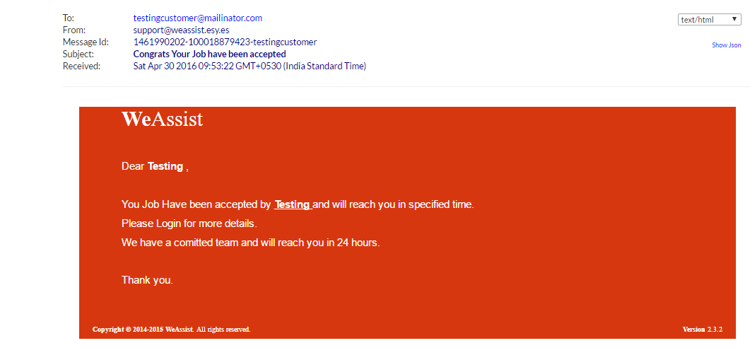

Figure 15.22 Email template

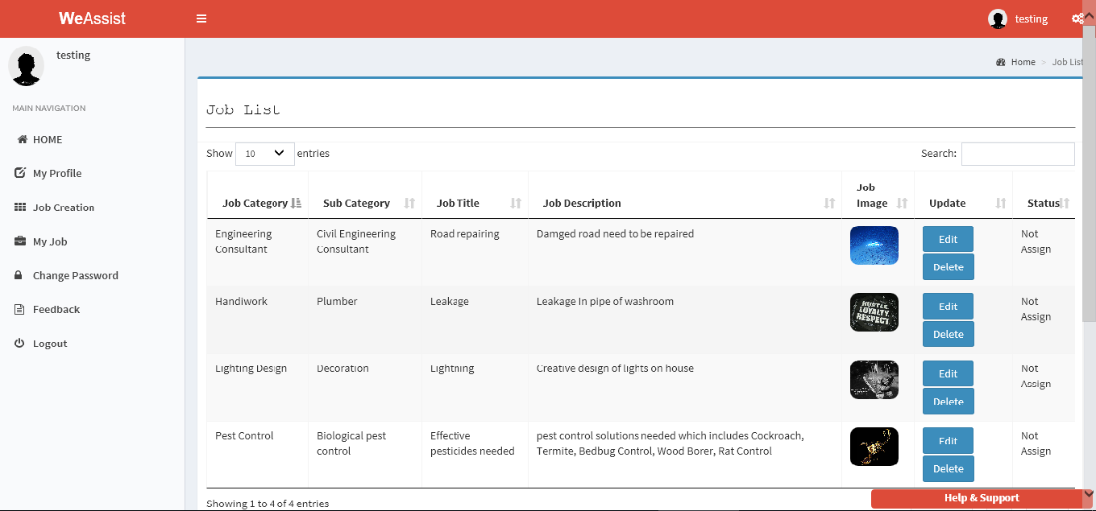

Figure 15.23 Job Listing (Custoemr)

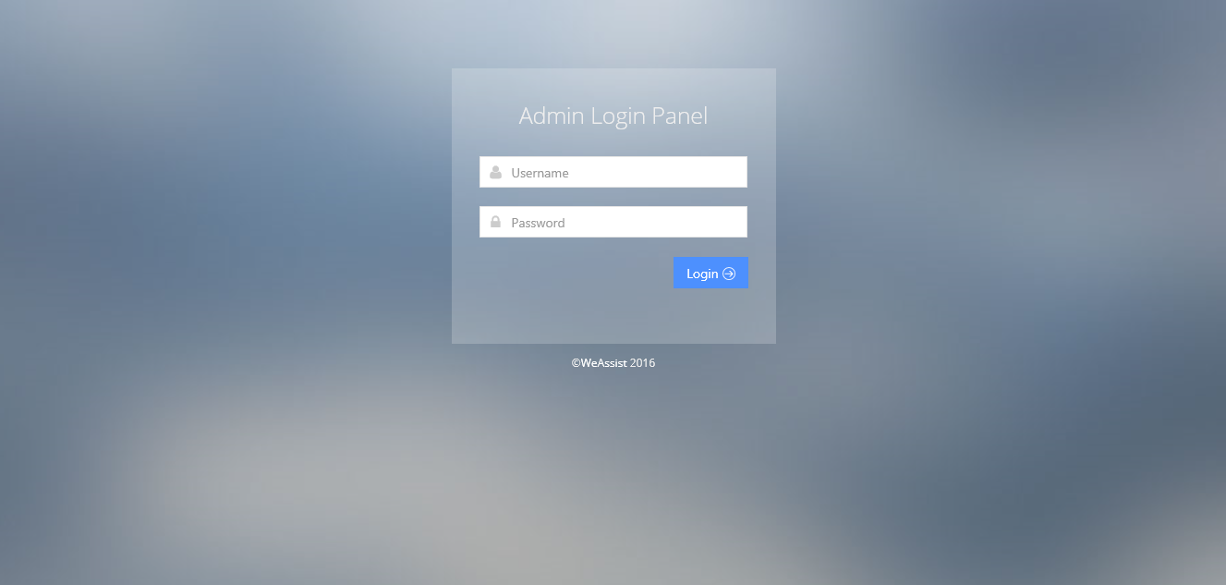

Figure 15.24 Admin login page

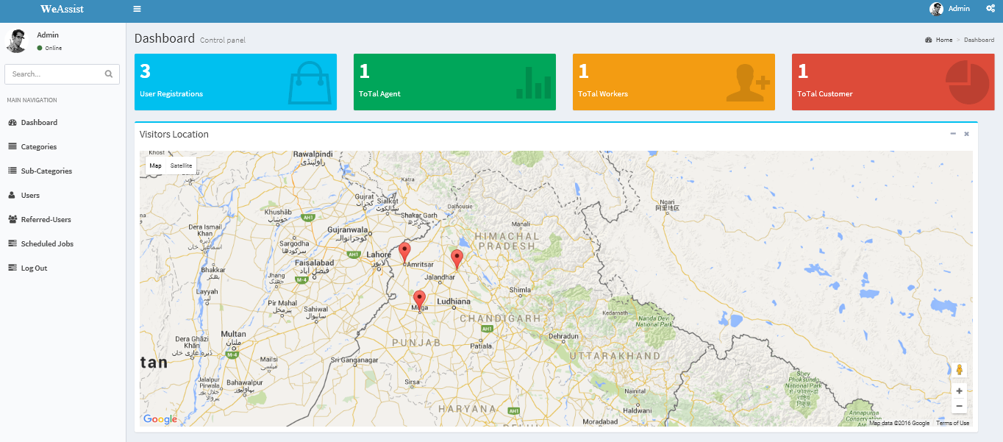

Figure 15.25 Admin Dashboard

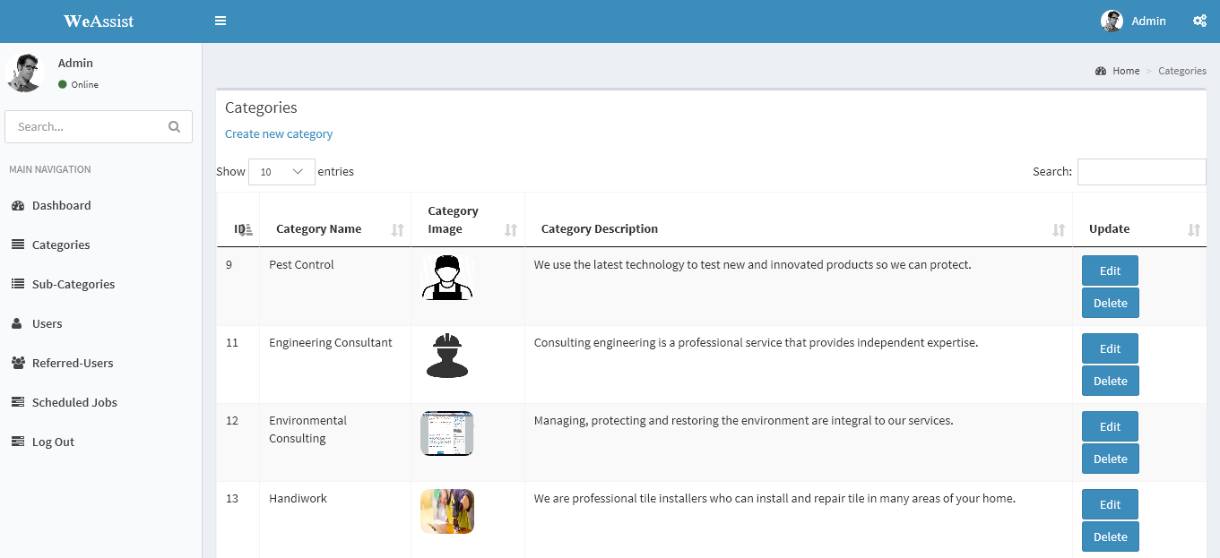

Figure 15.26 View all Categories

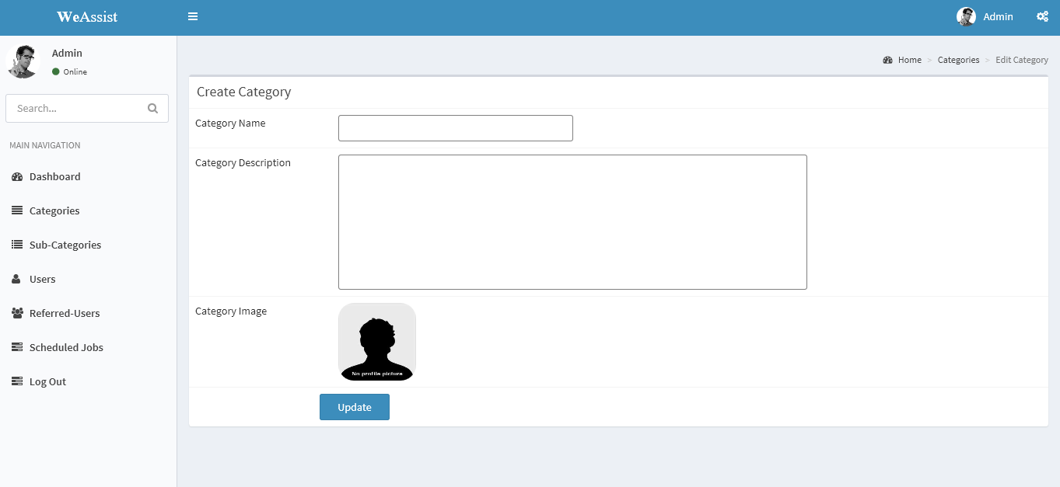

Figure 15.27 Create new Category(Admin)

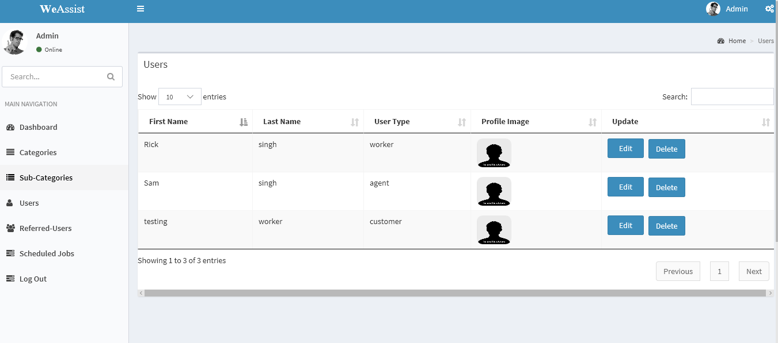

Figure 15.28 All User(Admin)

16. ARCHITECTURE

Architectural design of the project follows the MVC architecture.

Basic MVC Architecture, Model View Controller or MVC as it is popularly called, is a software design pattern for developing web applications. A Model View Controller pattern is made up of the following three parts: Model - The lowest level of the pattern which is responsible for maintaining data. View - This is responsible for displaying all or a portion of the data to the user. Controller - Software Code that controls the interactions between the Model and View.

The MVC abstraction can be graphically represented as follows.

Figure: 16.1 MVC Architecture

MODEL

VIEW

CONTROLLER

17. TESTING

Project testing makes a logical assumption that if all the parts of the project are correct, the goal will be successfully achieved. Inadequate testing or non-testing leads to errors that may not appear until months later. Another reason for project testing is its utility as a user –oriented vehicle before implementation. The best program is worthless if it does not meet user needs. Two types of testing:

**17.1 Functional Testing:**

Functions are tested by feeding them input and examining the output, and internal program structure is rarely considered. In the functional testing we have considered the following things

* We have identified the functions that the software is expected to perform means the member’s module, registration module and the reach us module.
* The creation of input data based on the function's specifications which are mentioned above.
* The determination of output based on the function's specifications.
* The execution of the test case which are not as per the function which the projects have to do.
* The comparison of actual and expected outputs.

**17.2 Structural Testing:**

 In Structural Testing we tests internal structures or workings of the Automation of the general store like data flow between the dates.

**Levels Of Testing:**

* **Validation testing:**

It provides final assurances that software meets all functional, behavioral & performance requirement.

There are three main components: -

* Validation test criteria (no. in place of no. & char in place of char)
* Configuration review (to ensure the completeness of s/w configuration.)
* Alpha & Beta testing -Alpha testing is done at developer’s site i.e. at home & Beta testing once it is deployed.
* **Unit Testing**

In this we test each module separately like Agent Module, Worker Module, Customer Module, Admin module and other related submodules. Unit testing focuses verification effort on the smallest unit of software i.e. the module. Using the detailed design and the process specifications, testing is done to uncover errors within the boundary of the module. All modules must be successful in the unit test before the start of the integration testing begins. In this project each service can be thought of a module.

* **Integrate Testing**

After unit testing, we have to perform integration testing. The goal here is to see if modules can be integrated properly, the emphasis being on testing interfaces between modules. This testing activity can be considered as testing the design and hence the emphasis on testing module interactions. In this project the main system is formed by integrating all the modules. When integrating all the modules we have checked whether the integration effects working of any of the services by giving different combinations of inputs with which the two services run perfectly before Integration.

* **System Testing**

Here the entire software system is tested. The reference document for this process is the requirements document, and the goal is to see if software meets its requirements. Here entire functionality has been tested against requirements of project and it is checked whether all requirements of project have been satisfied or not.

* **Acceptance Testing**

Acceptance Testing is performed with realistic data of the client to demonstrate that the software is working satisfactorily. Testing here is focused on external behavior of the system; the internal logic of program is not emphasized.

**18. CONCLUSION**

The package was designed in such a way that future modifications can be done easily. The

following conclusions can be deduced from the development of the project.

* Automation of the entire system improves the efficiency
* It provides a friendly graphical user interface which proves to be better when compared
* to the existing system.
* It gives appropriate access to the authorized users depending on their Permissions.
* Users can access site form anywhere in the world
* It effectively overcomes the delay in communications.
* Updating of information becomes so easier.
* System security, data security and reliability are the striking features.
* The System has adequate scope for modification in future if it is necessary.

**19. FUTURE SCOPE OF THE PROJECT**

• This website is design on the basis of single server and multiple clients therefore this

website can be further design to run on multiple servers with full-fledged computing

scalability.

• This website is design keeping in the mind database vender changes. Therefore, backend changes do not affect the application logic.

• This website can also be extended to be accessed on own PC more comprehensively. It

also avoids the manual work and the problems concern with it. It is an easy way to obtain

the information regarding the various Services offered in “WeAssist”.

• The Project Team have put Our best efforts of all what we have learnt during the ongoing semester in order to present the website regarding the information about the various activities

involved in online Home Services process.

• Still the project can be done in a better way. Many things have to be added such as Online payment and shops for worker.

• The next enhancement that we can add is the online transaction to the website for

receiving the payment online by the user who wants to pursue any Service.

**BIBLIOGRAPHY**

The following Sources were referred during the analysis and execution phase of the project:

https://pusher.com/tutorials/webrtc_chat

https://documentation.onesignal.com/docs/what-is-website-push

https://sendgrid.com/docs

https://developers.google.com/maps/documentation/javascript/

https://developers.facebook.com/docs/facebook-login/web

https://developers.google.com/+/web/signin/

https://developer.linkedin.com/docs/signin-with-linkedin